**How to Upload Artifacts to the Toddle Portfolio**

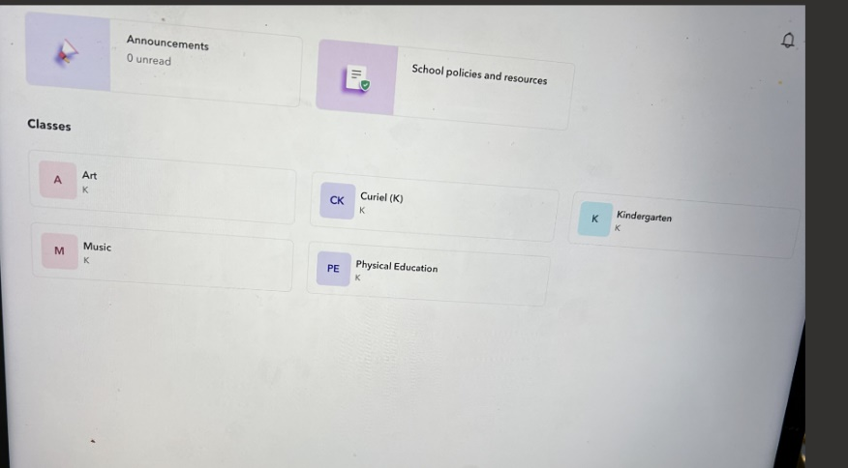Click on your classes name when you log in to toddle

Press the red plus sign (or create post) in the top corner to add a post. Select the type of post you are making.

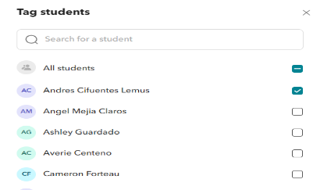

Tag the student

Tag learning goals, select all learning goals, the unit and learning experiences that are related.

**How to Access Student Portfolios (only on desktop)**

Log in to Toddle through the Teacher/Staff tab on the website When you log in you should see this screen.

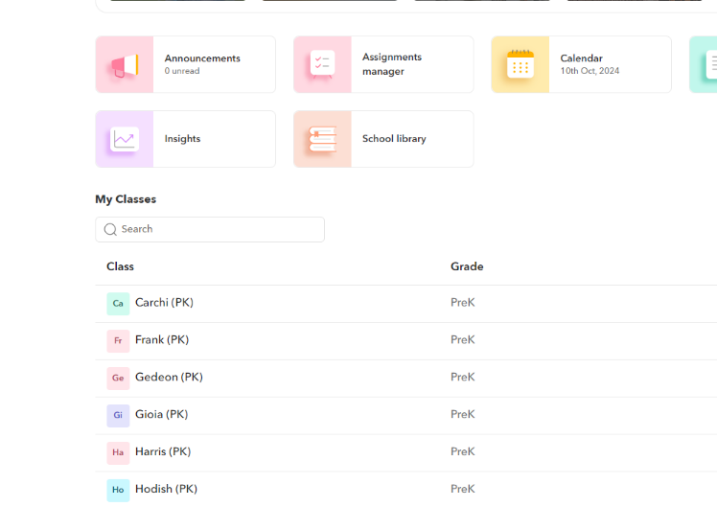Click on your class name.

Press the classroom and portfolio tab

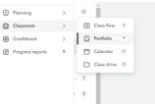

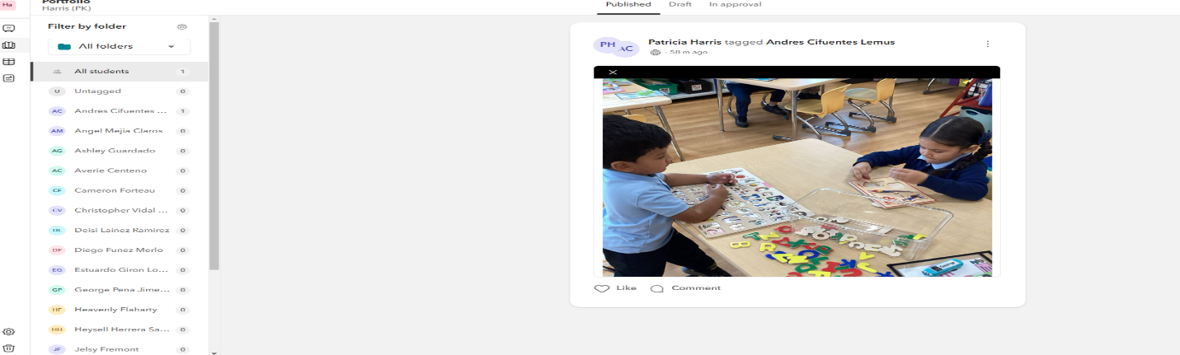You will then see your student portfolio by name.